

Walworth County prosecutor extends his expertise overseas
(Published Saturday, June 21, 2003)
By Brian Spinner/Gazette Staff
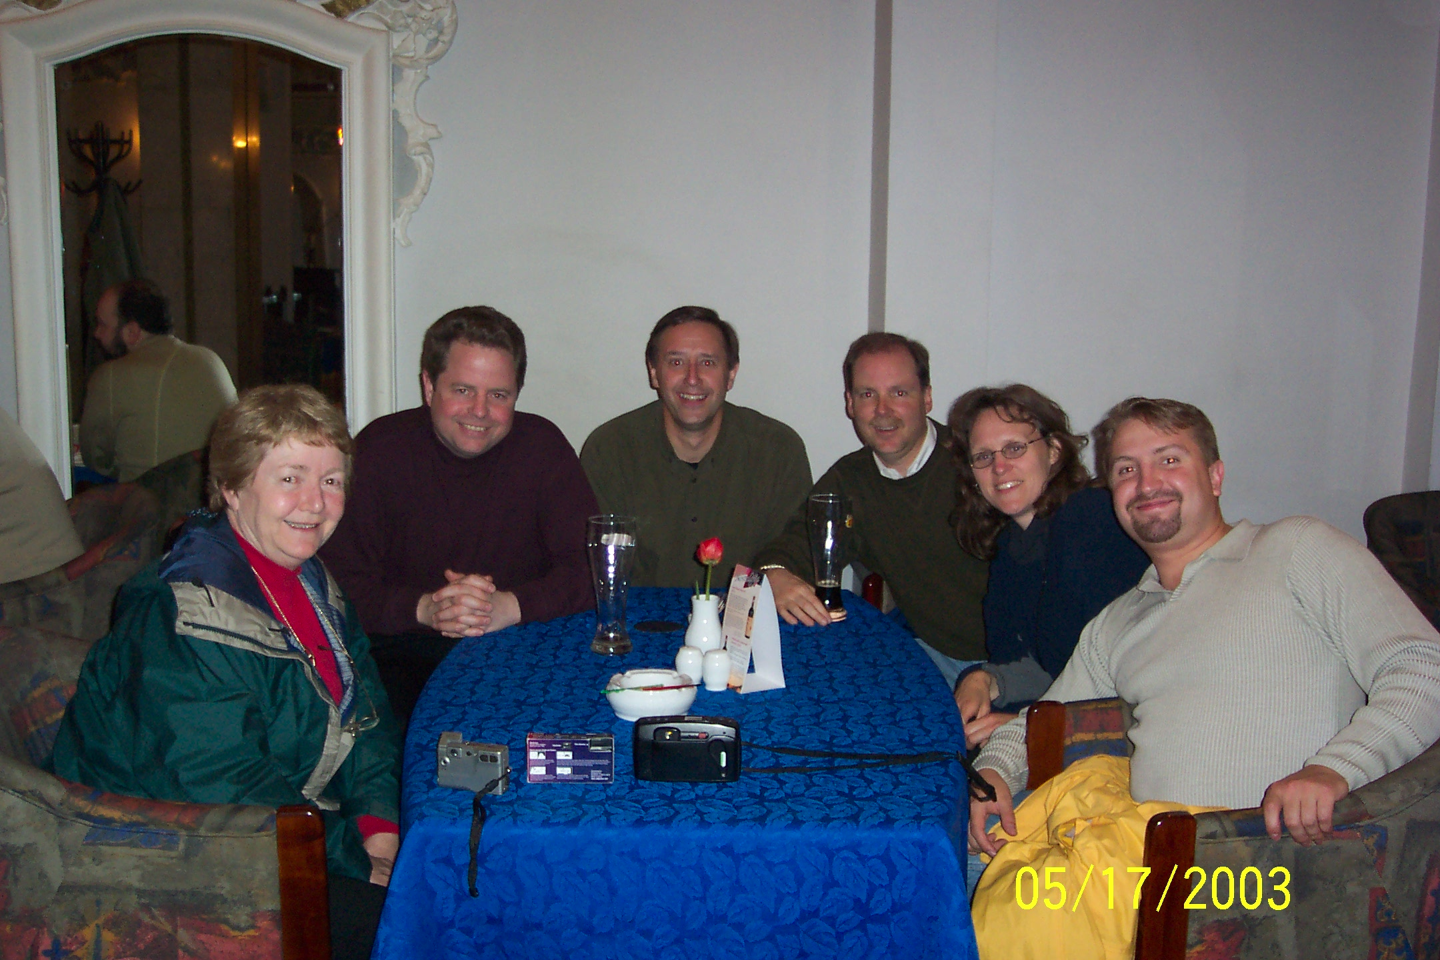
ELKHORN-Walworth County District Attorney Phil Koss is a known expert in the prosecution of domestic and child abuse cases by colleagues in Wisconsin and around the United States.
His reputation now stretches across the Atlantic Ocean to a former state of the late Soviet Union.
In May, Koss participated in a series of four child and domestic abuse seminars conducted throughout the Baltic country of Latvia. He participated with fellow delegates Margaret Flood, an independent social worker on child and adolescent treatment, Milwaukee County Judge Michael Dwyer and retired state Sen. Joanne Huelsman of Waukesha.
The seminars were designed to introduce United States justice, legislative and social welfare professionals to their Latvian counterparts and to exchange ideas about the two countries' systems. The seminars concentrated on legislative and legal issues related to child abuse and domestic abuse.
Kids First Fund, a nonprofit organization located in Shorewood, sponsored the seminars. Founded by Jay Sorensen and his wife in 1999 after their adoption of twin boys from a Latvian orphanage in 1997, Kids First raises money to provide shelter, care and programs for orphaned, handicapped, sexually and physically abused and pregnant children in Latvia.
The May seminars were the second exchanges sponsored by Kids First.
Flood also participated in the first exchange in 2001 and was the ringleader for this trip, Sorensen said. She contacted her fellow delegates late last spring, and they began preparing for their trip last fall.
She recruited Koss because of his work on several court cases in Milwaukee on behalf of Children's Hospital of Wisconsin.
"I recommended Phil based on my five and a half years of working with him," Flood said. "He is an astute prosecutor when it comes to child abuse issues."
Both Flood and Sorensen said the trip was a success. Flood estimated that 250 people attended the four seminars, including the Latvian minister of rights, five workers from his office and a high-ranking staff member from the U.S. ambassador's office in Latvia.
The seminars were broken into morning and afternoon sessions. In morning sessions, each U.S. representative presented an overview of their specialty and how it fits into the U.S. system. After their introductions, the group presented a case of a young girl reporting an assault to her teacher. The four then led a discussion on how the case would be handled in the United States.
"In the afternoon, we split into two sessions where I talked about presenting children's testimony and the common crimes against children and their penalties," Koss said. "Basically, it was an overview of the criminal justice system from beginning to end. The other group spoke to their peers and presented on foster care and domestic abuse."
The schedule allowed some time to meet with Latvian prosecutors and judges, Koss said.
"Some of the afternoon groups, where Judge Dwyer and I spoke, we would have maybe eight to 10 prosecutors and judges, so that allowed us to compare the systems in pretty small groups. We had some interesting dialogues."
Koss said the groups seemed to appreciate the investigative approach taken in the United States.
"I think they appreciated how we question children and some of our legislative ideas, such as mandated reporters and protection issues," he said.
However, Latvian prosecutors seemed to see the U.S. system's emphasis on defendant's rights as unfair, Koss said.
"I think they viewed our emphasis on defendant's rights as interfering with victims' rights and the truth," he said. "They did not understand, for instance, if the victim is forced to testify, why wouldn't the defendant be forced to testify.
"They just didn't understand the right to remain silent. It is not that they don't understand, they just don't think it is fair."
While the Latvian system was a national system, laws seemed to be applied differently in various parts of the country, Koss said.
"What seemed pretty clear was that they do not issue domestic abuse cases or child abuse cases unless there is physical evidence," he said. "Their viewing of what is enough evidence to go forward is different than ours. I think it is more of a cultural thing: 'We are not going to take one person's word against another persons word.'"
The idea of a 12-person jury of peers seemed inefficient to the Latvians, Koss said.
"They think jury trials with 12 people picked at random who don't know anything about a case can become very emotional and can easily acquit somebody because they feel sorry for them," Koss said.
The idea of a plea agreement is a foreign concept to them, he said.
"A person is either guilty or innocent. It is the presiding judge who determines guilt or innocence and orders the sentence."
Public responsibility is a large part of the Latvian culture, one of the differences between the two countries, Koss said.
"Our government formed from a basic distrust of power, preserving individual rights, while their idea of government is more a common good than an individual good," he said.
Sorensen agreed with Koss.
"There is a strong emphasis placed on property rights over human rights in Latvia," he said.
Sorensen said Latvian police wondered after one example presented by the U.S. delegates who would pay for a door broken down by police trying to stop an abusive situation or to get at an abuser.
During the week of their four-city tour, the delegation had little time to explore the country.
"We were rock stars without groupies," Koss said. "We were in the van at 7 a.m. and presenting from 9 to 5 and then back in the van for three hours, to the next town and unload and eat."
But Koss said he managed to travel throughout Riga and its surrounding countryside on the south end of the Baltic Sea.
Sorensen and Flood both said they observed tremendous improvement in the country's legal and justice system between their two trips.
Sorensen said his organization will continue its work in Latvia, supporting Bulduri, the group's orphanage, and with plans for a shelter for Latvian abused women and their families.
He has started planning the third seminar, a continuation of the seminars conducted in May. The next seminar is tentatively scheduled for 2004, and Koss again has been asked to participate.
Walworth County District Attorney Phil Koss and
friends in a restaurant in Latvia. Seated from right to left: Joanne Huelsman, Jay Sorensen, Judge Michael Dwyer, Koss, Margaret Flood, and Roger Grigulis of Latvia.

